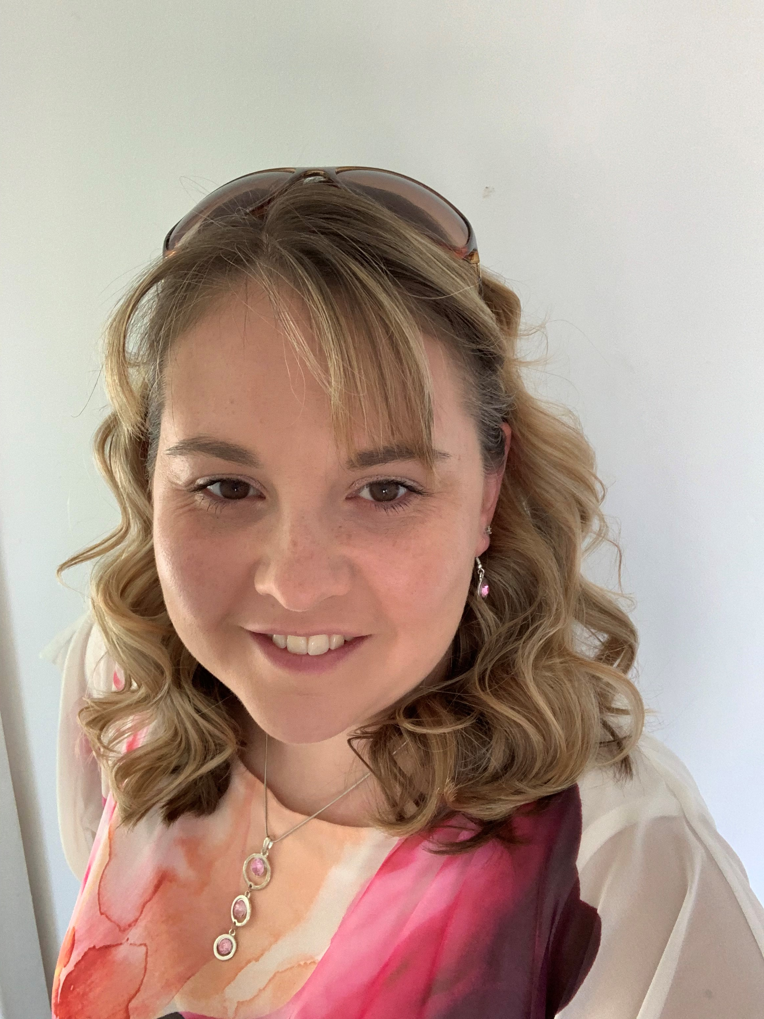
Laura Taw – Cert. GDPR – GP Senior Information Governance (IG) Consultant and Data Protection Officer (DPO)

Sussex – GP IG Data Protection Officer to all GP Practices
DPO to 1 Primary Care Federation

My Role
I would like to introduce myself as a Senior IG Consultant and Data Protection Officer (DPO). I am part of a team that have been appointed by the ICB to provide advice and guidance to practices on the IG agenda and further DPO services.
Providing practices with assistance in understanding the complex subject of data protection in the NHS. I will be able to assist with advising your practice/organisation on legislation including the UK GDPR and DPA 2018, the development of policies, procedures, training and auditing and advice and guidance, including incident management; subject access requests, and completion of the DSP Toolkit, to enable you to evidence how your practice/organisation meets their IG compliance commitments.

I will be able to review and provide advice on Data Protection Impact Assessments (DPIA’s) relating to what, how and with whom practices/organisations share their patient population data and how this can be managed in line with legislation and NHS requirements.

How
I have been appointed as your DPO and I look forward to meeting with you both virtually and face to face in person. I will also be available by telephone or email, to assist with any concerns or enquiries you have. I will be carrying out either reviews or initial assessments as virtual meetings.

Myself
I am married with two children and live in a small village near Fareham. We live close to the beach and enjoy spending many sunny days paddling in the sea.

I have worked for the NHS for 15 years. I spent 11 years working for an Acute Trust, in many different roles covering Administration in both inpatients and outpatients. I was excited to take on a new role as a DPO working with GP Practices. In April 2020, an opportunity presented itself to become part of a specialised team of GP IG Consultants and DPO’s where I could share experiences and learn so much more about GDPR and Data Protection in Primary Care.
I now lead the team of GP IG consultants and DPO’s within Primary Care.

I enjoy working with GP Practices and Primary Care Federations, and I am excited to continue to provide support and training to you and am very much looking forward to working with you.

Contact details
Email: laurataw@nhs.net
Mobile: 07879840512
Working Days: Monday to Friday – please see my email signature for specific hours.

