Advocacy support
- POhWER support centre can be contacted via 0300 456 2370
- Advocacy People gives advocacy support on 0330 440 9000
- Age UK on 0800 055 6112
- Local Council can give advice on local advocacy services
- Other advocates and links can be found on this PHSO webpage

Further Action
If you are dissatisfied with the outcome of your complaint from either Sussex ICB or this organisation, then you can escalate your complaint to Parliamentary Health Service Ombudsman (PHSO) at either:

Milbank Tower
Milbank
London SW1P 4QP

Citygate, Mosley Street
Manchester M2 3HQ

Telephone: 0345 015 4033
www.ombudsman.org.uk

Carisbrooke Surgery
St Leonards Medical Centre
126 Bexhill Road
St Leonards on Sea
TN38 8BL
01424 423190

The Complaint Process
Carisbrooke Surgery


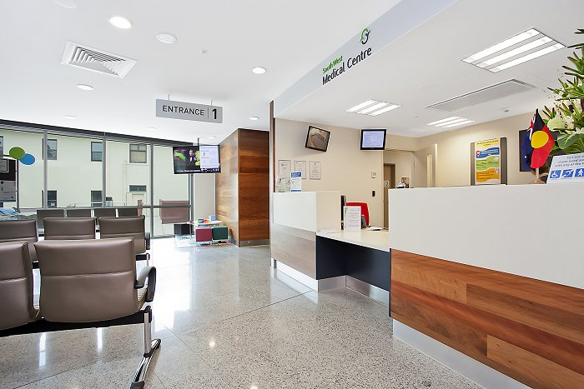

Talk to us
Every patient has the right to make a complaint about the treatment or care they have received at Carisbrooke Surgery.
We understand that we may not always get everything right and by telling us about the problem you have encountered, we will be able to improve our services and patient experience.

Who to talk to
Most complaints can be resolved at a local level. Please speak to a member of staff if you have a concern and they will assist you where possible. Alternatively, ask to speak to the Complaints Manager, Claire Critoph, Practice Manager, but note this may need to be a booked appointment.

If for any reason you do not want to speak to a member of our staff, then you can request that the Integrated Care Board (ICB) investigates your complaint. They will contact us on your behalf:
NHS Sussex
Sackville House,
Brooks Close,
Lewes,
BN7 2FZ
Telephone: 0300 140 9854 (excluding weekends and bank holidays)

Complaints email: sxicb.complaints@nhs.net

A complaint can be made verbally or in writing.
Time frames for complaints
The time constraint on bringing a complaint is 12 months from the occurrence giving rise to the complaint, or 12 months from the time you become aware of the matter about which you wish to complain.
The complaints manager will respond within three business days to acknowledge your complaint.
We will aim to investigate and provide you with the findings as soon as we can and will provide regular updates regarding the investigation of your complaint
Investigating complaints
We will investigate all complaints effectively and in conjunction with extant legislation and guidance.
Confidentiality
We will ensure that all complaints are investigated with the utmost confidentiality and that any documents are held separately from the patient’s healthcare record.
Third party complaints
We allow third parties to make a complaint on behalf of a patient. The patient must provide consent for them to do so. A third-party patient complaint form is available from reception.
Final response
We will issue a final formal response to all complainants which will provide full details and the outcome of the complaint. We will liaise with you about the progress of any complaint.

