Advocacy support
- POhWER support centre can be contacted via 0300 456 2370
- Advocacy People gives advocacy support on 0330 440 9000
- Age UK on 0800 055 6112
- Local Council can give advice on local advocacy services

If you are dissatisfied with the outcome of your complaint you can seek further guidance from:
NHS England
PO Box 16738
Redditch B97 9PT
Tel: 03003 112233
england.contactus@nhs.net

Or alternatively complain to the:

Parliamentary Health Service Ombudsman
Milbank Tower
Milbank
London SW1P 4QP
Tel: 0345 015 4033
www.ombudsman.org.uk

Carisbrooke Surgery
St Leonards Medical Centre
126 Bexhill Road
St Leonards on Sea
TN38 8BL
01424 423190
The Complaint Process
Carisbrooke Surgery

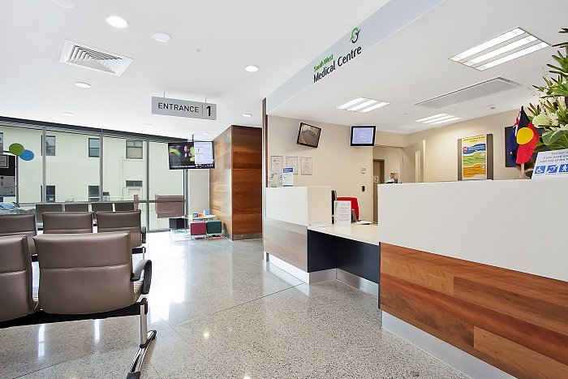

Talk to us
Every patient has the right to make a complaint about the treatment or care they have received at Carisbrooke Surgery.
We understand that we may not always get everything right and by telling us about the problem you have encountered, we will be able to improve our services and patient experience.

Who to talk to
Most complaints can be resolved at a local level. Please speak to a member of staff if you have a complaint; all our staff are trained to handle complaints effectively. Alternatively, ask to speak to the Complaints Manager, Claire Critoph, Practice Manager.

At Carisbrooke Surgery the
Complaints Manager is :
Claire Critoph, Practice Manager and they are supported by the Responsible Officer who is:
Dr W de Haan

A complaint can be made verbally or in writing. A Complaints Form is available from reception.

Time frames for complaints
The time constraint on bringing a complaint is 12 months from the occurrence giving rise to the complaint, or 12 months from the time you become aware of the matter about which you wish to complain.

The Complaints Manager will respond to all complaints within three business days. Furthermore, they will provide regular updates for you regarding your complaint, whilst aiming to have the complaint completely resolved within 40 days

Investigating complaints
Carisbrooke Surgery will investigate all complaints effectively and in conjunction with extant legislation and guidance.

Confidentiality
Carisbrooke Surgery will ensure that all complaints are investigated with the utmost confidentiality and any documents are held separately from the patient’s healthcare record.

Third party complaints
Carisbrooke Surgery allows a third party to make a complaint on behalf of a patient. The patient must provide consent for them to do so. A Third Party Patient Complaint Form is available from reception.

Final response
Carisbrooke Surgery will issue a final formal response to all complainants which will provide full details and the outcome of the complaint. Further information is detailed in our practice policy.

